The children can start training from the age of 6 years.  The benefits that this holds for your child are:

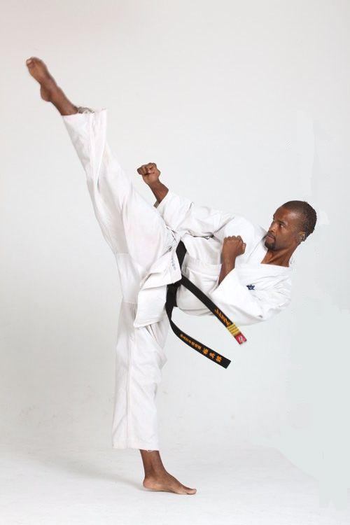

***Did you know***:

***Sensei Simphiwe won the Russian U80kg Men Championships held in Moscow Russia in 2000***

## letterheads!

**STUDENT OF THE MONTH**

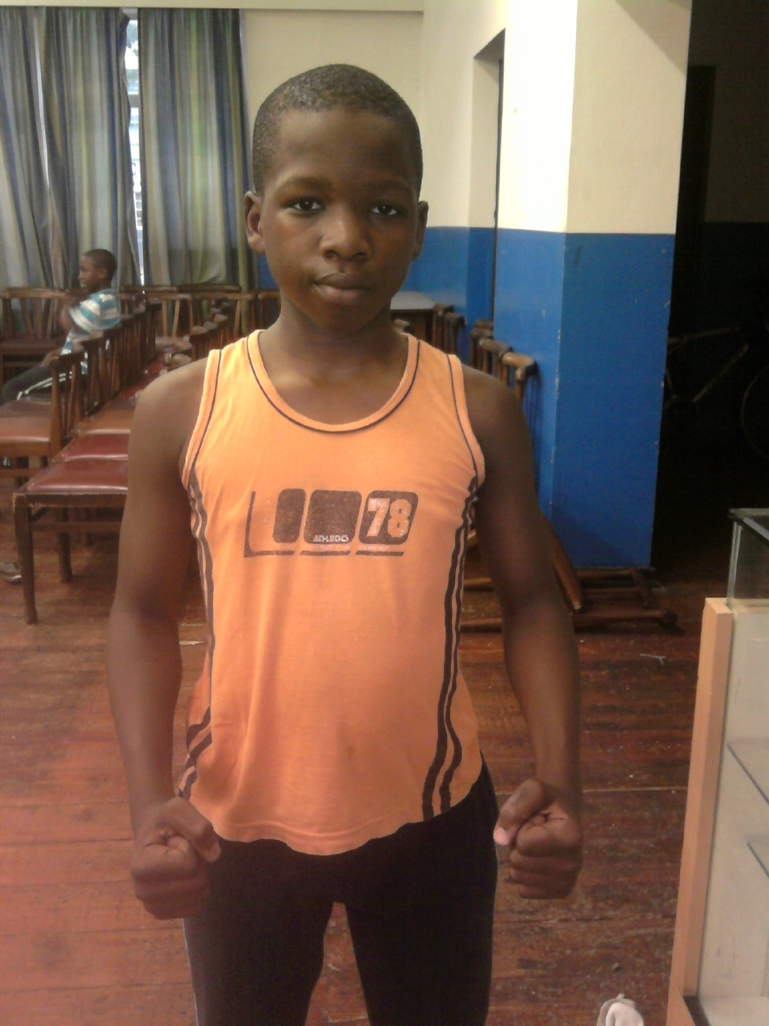

***Name: Sango Mbinyashe***

***Age: 12 years***

***Address: Vincent***

***School: Hudson Park Primary – Gr7***

***Favouring exercise: Squats***

***Favourite technique: Mae-geri (front kick)***

***Favourite food: Cheese burger & Umvubo***

***Faurite school subject: Maths & Science***

***Joined karate because?: Inspired by uncle Luqaqambo***

***Simblings: Sihle & Siyamkela***

***Sango hopes to be a Black Belt one day!***

Contents

tECHNIQUES LEARNT

sTUDENT OF THE MONTH

2011 eVENTS

Special Interest Story

**April – June 2011 Events:**

* ***Karate South Africa Children & Young Lions tournament (Port Elizabeth – Motherwell) – 09 April 2011***
* ***International training camp (Cape Town – Stellenbosch) – May 2011***
* ***Eastern Cape Tournament (East London) – Date to be confirmed***

Congratulations! Your son/daughter has officially completed a full month as a Karateka.

It gives me great pleasure to welcome all my new students to this great art of Karate. I am committed and passionate about the sport and I am hoping to translate the same passion to my students.

This is our first newsletter which we will use to communicate with you as the parent or guardian. Your participation and support will be highly appreciated.

Please enjoy this issue and learn more about what we do.

Should you need any further information or if you have any concerns regarding your child, please feel free to contact me.

Yours in sport.

**SENSEI: SIMPHIWE DLULANE**

***SI***

Fence graphic

|  |  |
| --- | --- |
| bullet aLL ABOUT kARATE | Improved co-ordination and balance |
| bullet | ***NOTE:***  ***We are an internationally registered organization.***  ***We also have training camps and tournaments for kata and kumite (fighting).***  Greater awareness and control of the body |
| bullet | Healthy exercise |
| bullet | Increased confidence |
| bullet | Gradual improvement of focus and concentration |
| bullet | Emphasis on respect and courtesy |
| bullet | Creates a sense of discipline and self- discipline |
| bullet | Counters bullying and blustering |
| bullet | Builds a positive self -image |

**The class times:**

|  |  |
| --- | --- |
| Mondays & Thursdays  **Progress thus far….**  The students have been hard at work, learning new hand and leg techniques each week.  The following techniques have been taught:  (please encourage your child to practice these regularly)  Hand techniques (Kihon Geiko): Stances (dachi)   * Seiken chudan tsuki 1. Zenkutsu dachi (Forward stance) * Mae-gedan braai 2. Kokuntsu dachi (Back stance) * Jodan uke * Uchi uke   Leg techniques (Keri kihon geiko):   * Mae-keage * Mawashi geri * Kantsetsu geri   Two (2) katas were also learnt and these require much more practice as they combine hand and leg movements:(refer to attached for caption)   * 1st Kata - Taikyoku sono ichi (basic kata using hand techniques) * 2nd Kata - Sokugi taikyoku sono ichi (basic kata using kicking techniques)   You can also find interesting articles and information for your friends to read by accessing the World Wide Web.  Much of the content you put in your newsletter can also be used for your Web site. Microsoft Word offers a simple way to convert your newsletter to a Web publication. So, when you’re finished writing your newsletter, convert it to a Web site and post it.  The purpose of a newsletter is to provide specialized information to a targeted audience. Newsletters can be a great way to communicate with family and friends on a regular basis. | 17h30 – 19h00  F:\My Docs\Karate\My Pics\Japan 2003, World Championships.jpg***D:\Documents and Settings\DlulanD\My Documents\My Pictures\Simphiwe in Action.JPG***29 |

|  |  |
| --- | --- |
|  |  |
|  |  |
|  |  |
| KyokushinKan Karate  8 5th Avenue, Gonubie  Phone – (043) 740 5486  Cell – 071 0897 391 / 072 7622 959  E-mail address: [simphiwe@fullcontactkarate.co.za](mailto:simphiwe@fullcontactkarate.co.za)  Website: www.fullcontactkarate.co.za |  |
|  |  |
|  |  |
|  |  |

We’re on the Web!

See us at: www.fullcontactkarate.co.za